# **Varys – The Game of Automata!**

Instructions: How to execute

**Step 1:** Run Varys.exe

* It will create folder app_data.
* Starts UI –

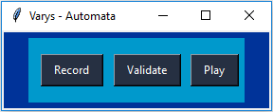

**Step 2:** Capture Event – Use Record

* Press Record

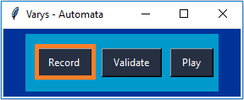

* Once recording started, start your event recording by performing your task.
* Once your task is completed, press ‘esc’ to end your recording.
* Inside “app_data/events” folder events.json file will be created, which contains all the events details.

**Step 3:** Capture Validation Image – Use Validate

* Press Validate

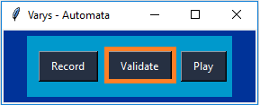

* Once validate button is active, it will give you a snapping cursor, which helps you to select area (green color box) in your current screen.

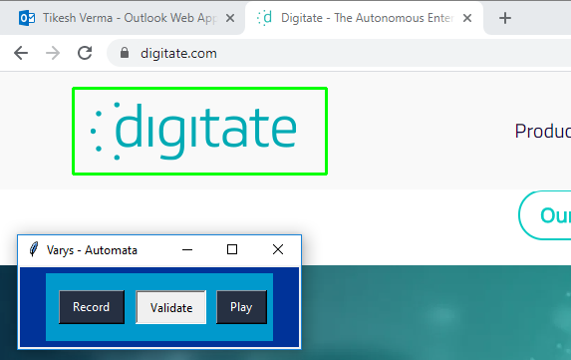

* In above example, digitate logo is selected for snap.
* Once you have selected your validation image, press ‘w’ to take snap.
* Inside “app_data/validation” folder, snap is stored with name as a number.

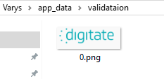

**Step 4:** Creating automata – Example

* Open run command using win+r
* Type : chrome
* Press: enter > Chrome opens
* Type : <https://digitate.com> in search bar
* Press: enter
* Wait for site to fully load
* Scroll to navigate page.

Automata creation -

1. Event.json file created after performing above task -



1. Event.json file contains events which can be modify to improve performance.
   1. Each key press for words, creates single event in events.json file. For example in events.json file, there will be 6 event to type ‘chrome’. Instead of having 6 different event all this 6 event can be replace with single event containing ‘chrome’ as single word.

{

"device": "keyboard",

"event": "key-write",

"key": "Chrome"

}

* 1. Combination of keys such ‘ctrl+c’ or ‘ctrl+v’ are called hotkeys. In event.json file, there will be two different events for this combination of keys ‘ctrl’ and ‘c’. We can replace this two events keys with single event containing ‘ctrl,c’ as single combination.

Event for run command(Hotkey – win+r)

{

"device": "keyboard",

"event": "key-hotkey",

"key": "win,r"

}

* 1. To add image validation, we first need to identify after which event we need to validate. Once event is identified, we need to add validation event. In validation event we need to define few things –
     1. valid_seq: This is the sequence id of image to be validate. This is same as name of image created under app_data/validation folder.If you want snap named 0.png to be validate, than we have to give 0 as valid_seq.
     2. duration: This is the timeout period for the image to get validate. If an image is not getting validate, than after given duration( value in minutes) it will get expire and automata will get terminated.

{

"device": "image",

"event": "validate",

"duration": 5,

"valid_seq":0

}

* 1. After applying all this modification and changes to event, we can create a new json file with any name and place that file inside app_data/automata folder.



* 1. We can create multiple automata json file inside automata folder. It will get executed one by one in ascending order of file name.

**Step 5:** Run automata: Play

* Press Play

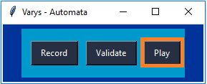

* It will start executing your automata.

Events: Use and description

**Event 1:** Mouse

* Click :

{

"device": "mouse",

"event": "click",

"x": 799,

"y": 276,

"button": "Button.left"

}

* + This will perform click at x,y coordinate on your screen.
  + Button defined which click event want to perform-
    - Button.left – left Click
    - Button.right – Right Click

**Event 2:** Keyboard

* key-press:

{

"device": " keyboard",

"event": "key-press",

"key": "'i'"

}

* + This will perform key press ‘I’ on your machine.
  + Key – Any key of your keyboard.
* key-write:

{

"device": " keyboard",

"event": "key-write",

"key": "Text to write"

}

* + This will write whole text on your machine.
  + Key – Contains words or sentence.
* key-hotkey:

{

"device": " keyboard",

"event": "key-hotkey",

"key": "win,r"

}

* + This will perform hotkey combination.
  + Key – Contains sequence of hotkey.

**Event 3:** Validate

* Validate :

{

"device": "image",

"event": "validate",

"duration": 5,

"valid_seq":0

}

* + This will validate image on current screen, if the valid_seq id’s image is available on screen.
  + Duration is timeout period to be set for min time wait for validation.

Examples and Demo Automata

**Example 1: Introduction.**

* Run Varys.exe
* Go to Documents\automata_example\intro
* Copy introduction.json to you app_data/automata folder.
* Press Play.

**Example 2: Open Digitate web site.**

* Run Varys.exe
* Go to Documents\automata_example\digitate_website
* Copy and replace automata and validation folder to you app_data folder.
* Press Play.

**Example 3: Send Messages using teams.**

* Run Varys.exe
* Go to Documents\automata_example\teams_send_message\automata
* Open message.json
* Replace @EMPID with empid , eg :@1360969
* Replace “Message to be send” with your message
* Copy message.json to you app_data/automata folder.
* Create multiple message.json file for different user or empid.
* Message will be sent in ascending order of file.
* Open teams in full screen.
* Press Play.